System Descent

Nottingham Trent University

Prototype Spec Document

Theodore Theodorou | n0719679

## Brief description (blurb on back of box) (10 marks)

After waking up upon an operating table without remembering who you are or how you got there, you were shocked to see that your limbs were replaced with robotic counterparts. Fortunately, it seemed that your bionic arm was equipped with several munitions that somehow you felt you were going to need. To escape the research facility where you were assembled means a long and treacherous descent to the ground floor. During this endeavour you will encounter various oppositions designed to hinder your course, and it is your job to overcome everything this mysterious building throws at you.

## Description of Game Play

This game will be designed to run as an executable file for windows 10 to increase the portability of the game. When you launch the game, you will be presented with a title screen where you can select either “Start Game”,” Options”, or “Exit Game”. In the Options page you will be able to alter certain game mechanics like music volume and SFX volume. Upon clicking Start Game, the user will be taken to an instructions page where they will be able to check the controls before playing the game. The controls are fairly simple: left and right arrow keys to move, up arrow key or space to jump, down arrow key while moving to slide, z to shoot, and x to melee. After checking the instructions page, the user can press any key to continue to the main game screen where the game will play out, and at this point the music will begin to play.

The player will be presented with the robot they will be controlling and see it standing in front of an open doorway which is presumed to be the operating room where it was created. After giving the player a few seconds to get used to the controls, the main gameplay mechanic will play out: the platforms that the player stands on will begin to rise, and it is the players job to make sure they don’t get flattened between a platform and the top of the screen. Therefore, it is clear that for the player to progress they need to move downwards, which is done by falling between gaps randomly generated in the platforms. To also slow the progression of the player there will be numerous randomly generated obstacles such as saws, spikes and acid, that will hurt the player and decrease their HP (Health Points) if they are touched. The player can also lose HP if they are hurt by the attacks of enemies, which will spawn at set periods of the game playing out. For that reason, the two ways for the player to die is if they are trapped between a platform and the top of the screen which causes instant death, or if the player runs out of HP.

My game will consist of two levels with a checkpoint in-between. When the player has reached the second level the game will become more difficult- more dangerous objects will spawn in, enemies will be harder to kill, and the platforms will raise at a higher rate making time more of an issue. To reach the second level the player needs to defeat the first boss, who will be similar to the other enemies but will have different attacks and hold more HP. The second boss in the second level guards the exit and upon defeating will allow the player to exit the building and ultimately complete the game. The player is given three lives to complete a level and has opportunities to collect more as they play. The player is also able to pick up energy, which is found by destroying static objects generated by the game. Energy is consumed when the player shoots their weapon so will need to be replenished to take down the bosses.

## Screen Images

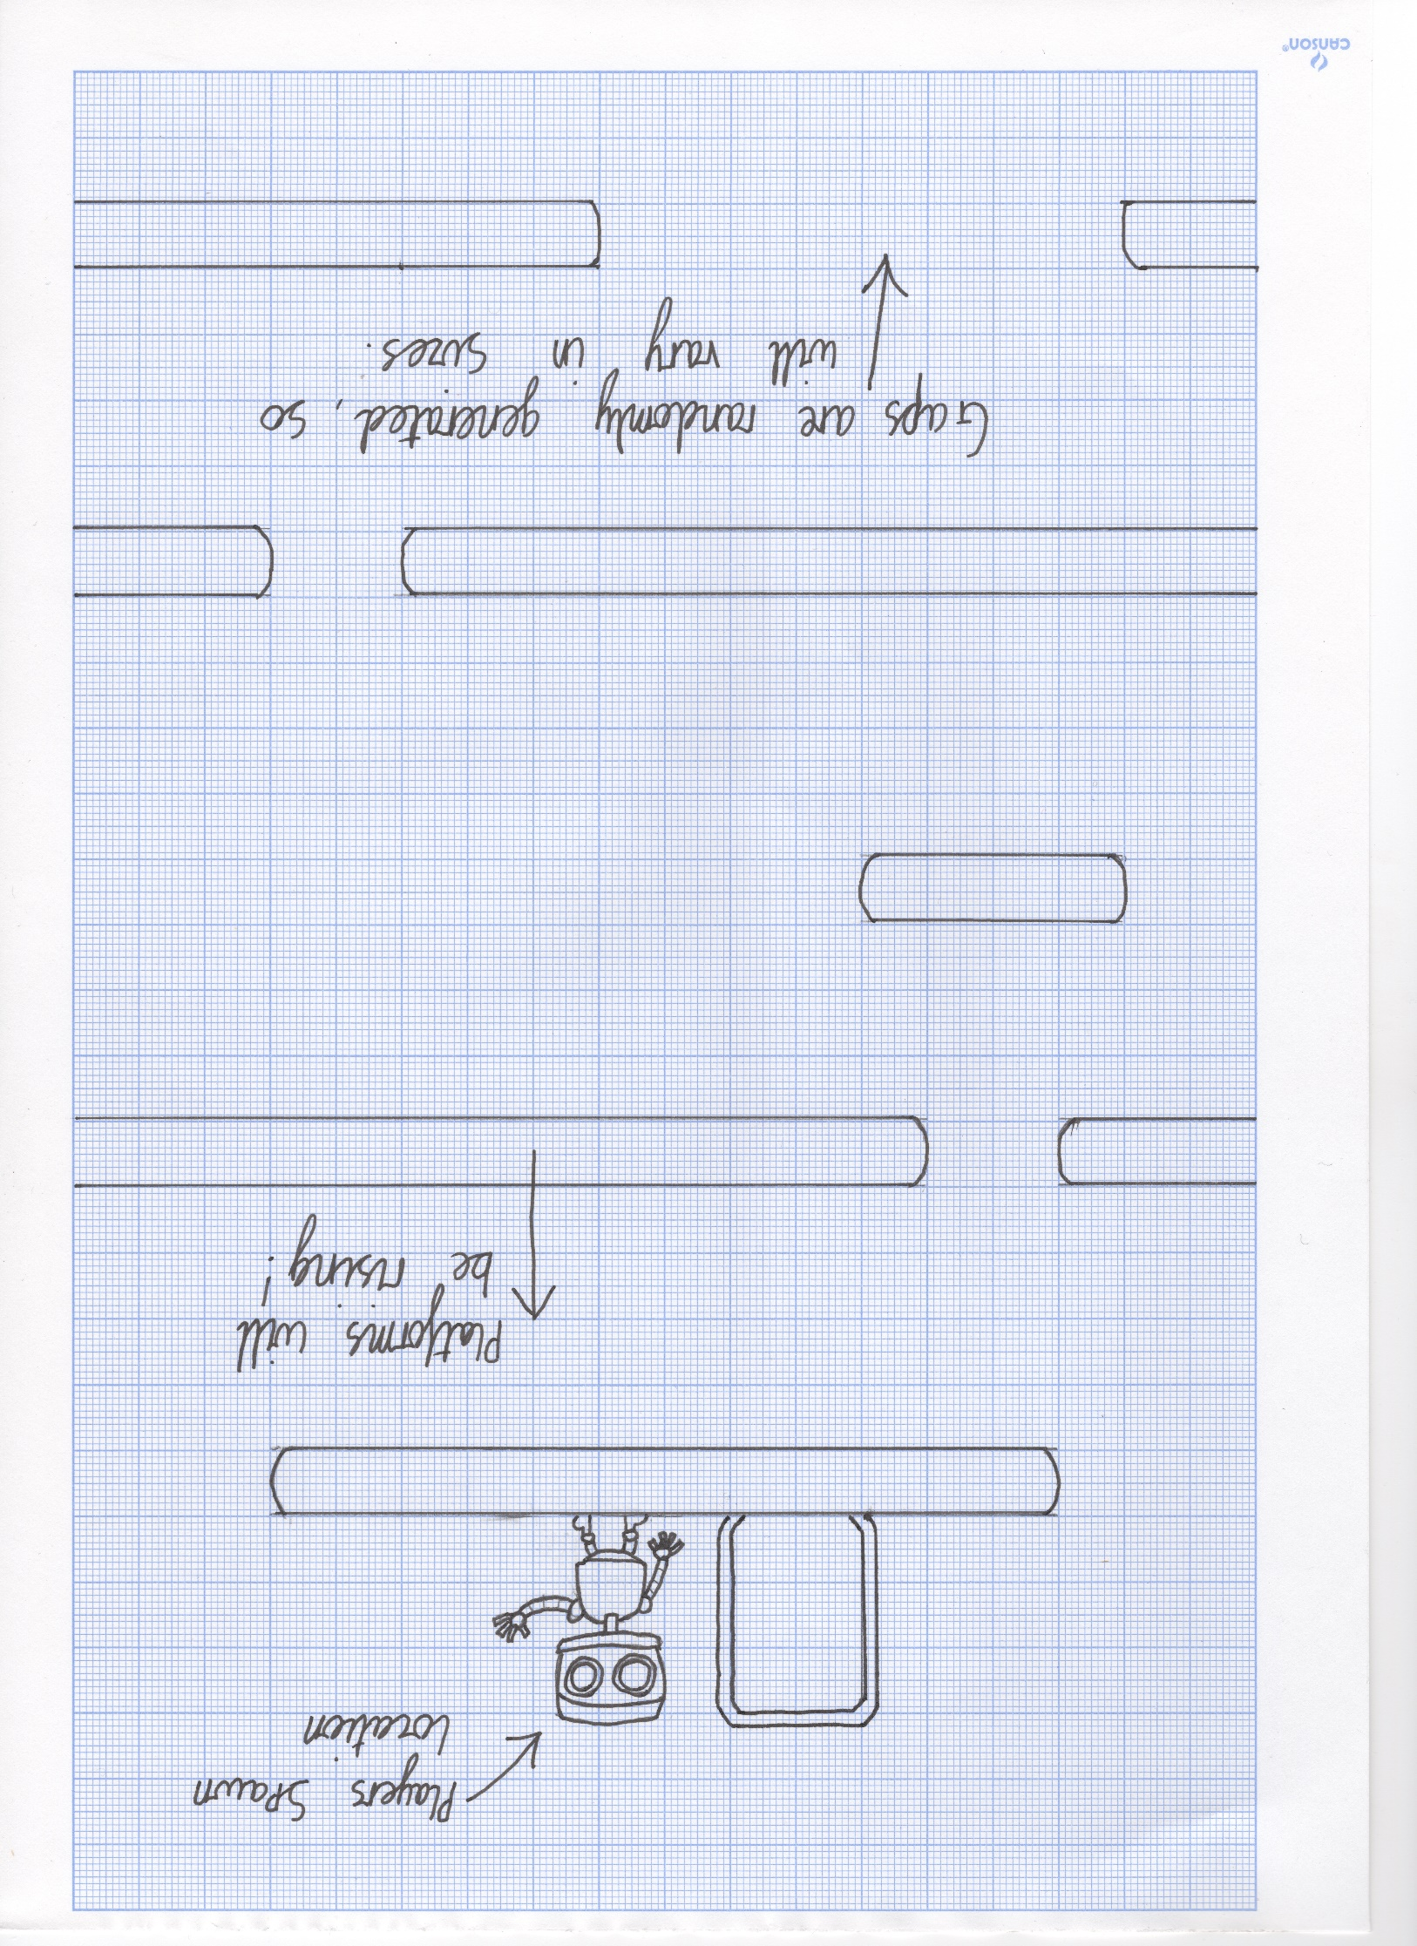**First Sketch of when the player starts the game**

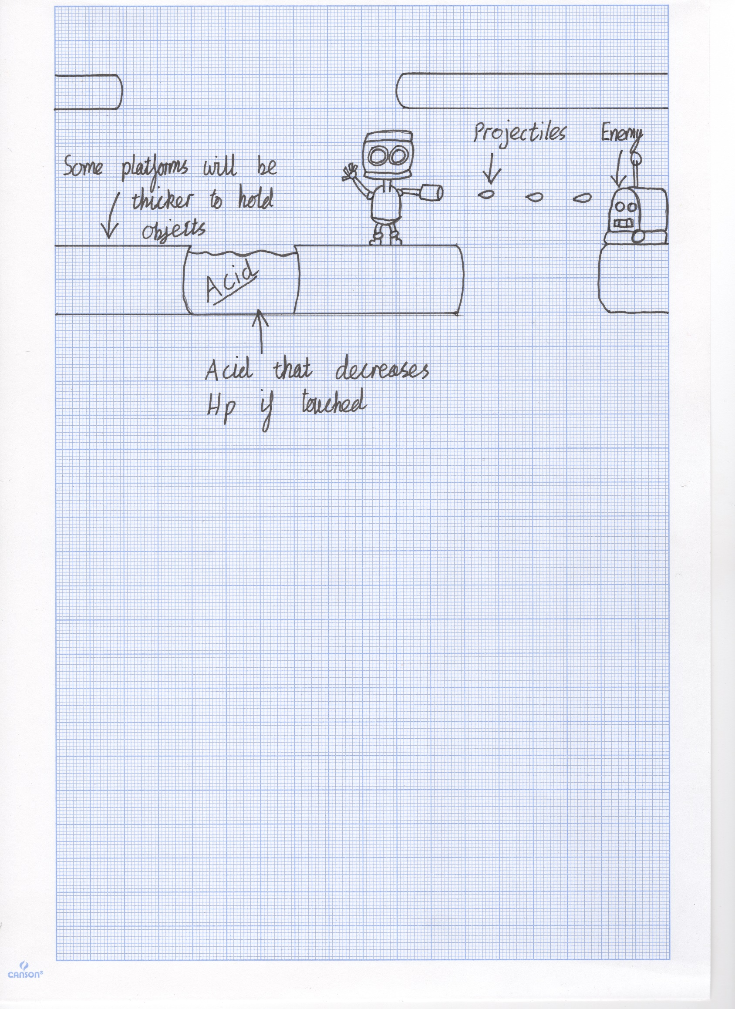

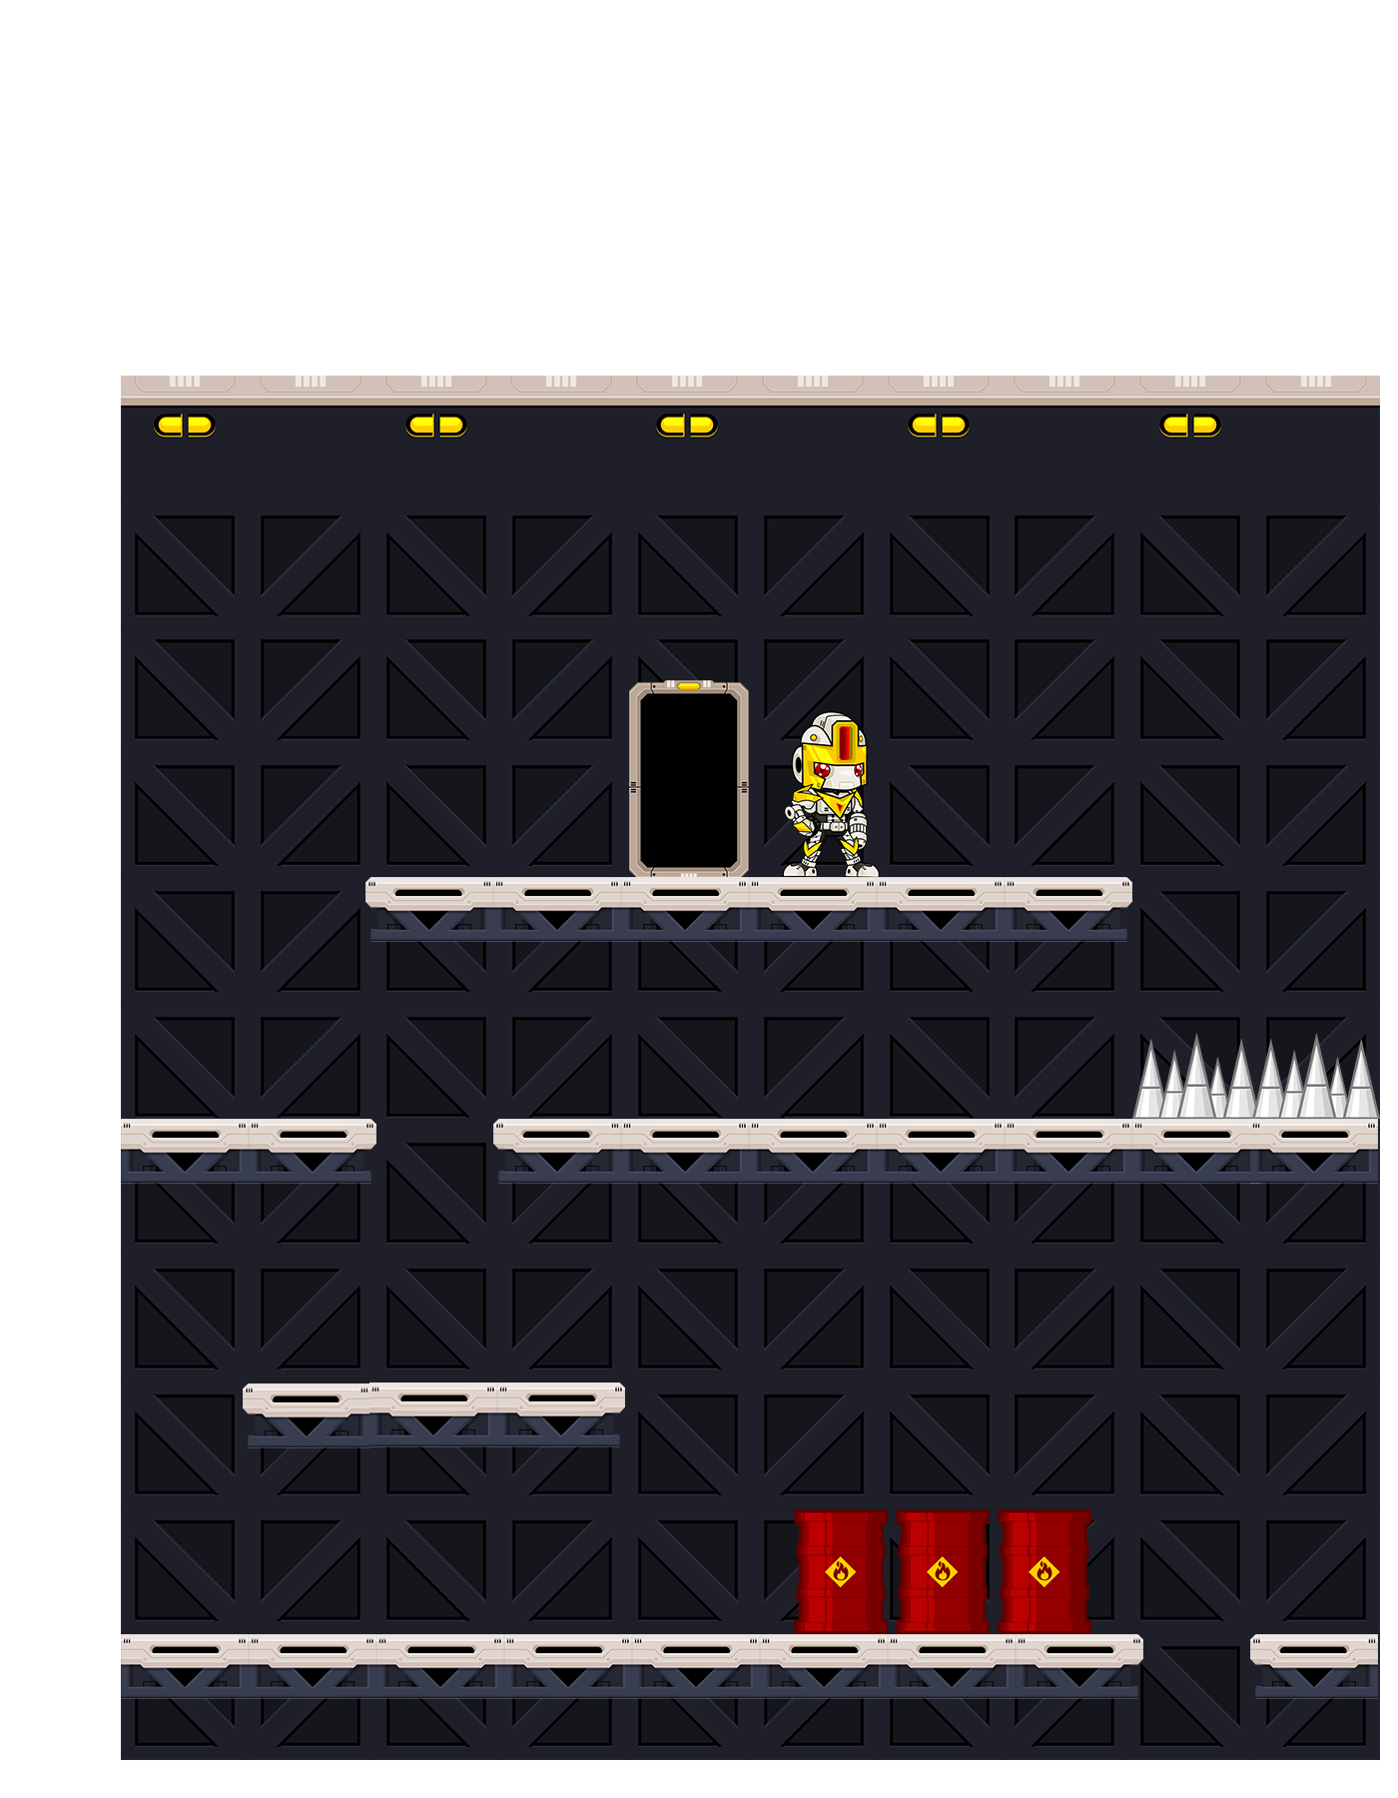**Second set of drawings created in photoshop. Found a free sprite strip online for the player. This screen shows where the player spawns in, and how they need to move downwards to progress through the game.**

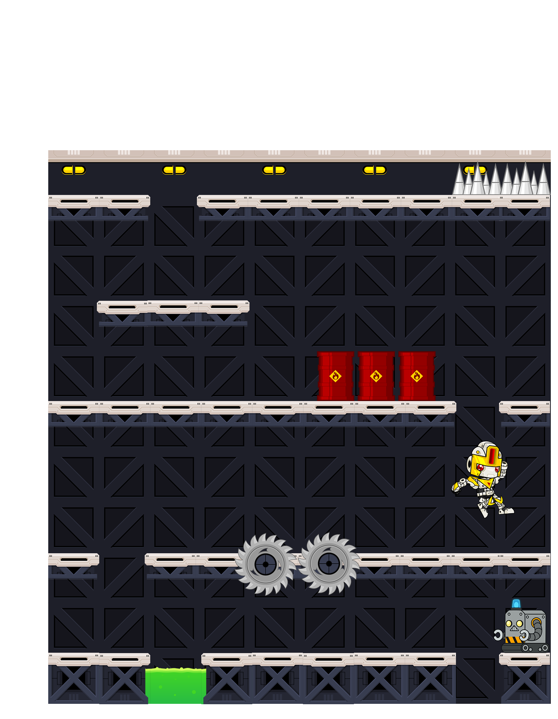**This screen shows how the player will move around the map- falling between the gaps in the platforms to avoid being trapped between a platform and the top of the screen. You can also see that in these designs I decided to add the static entities such as the explosive barrels, saws, and acid. All static entities will have a Boolean attribute to determine whether they can be broken. The explosive barrels will be breakable and will use particle physics to emulate the fire, which will damage the player if touched. The saws and acid are not breakable and therefore will need to be avoided by the players movement.**

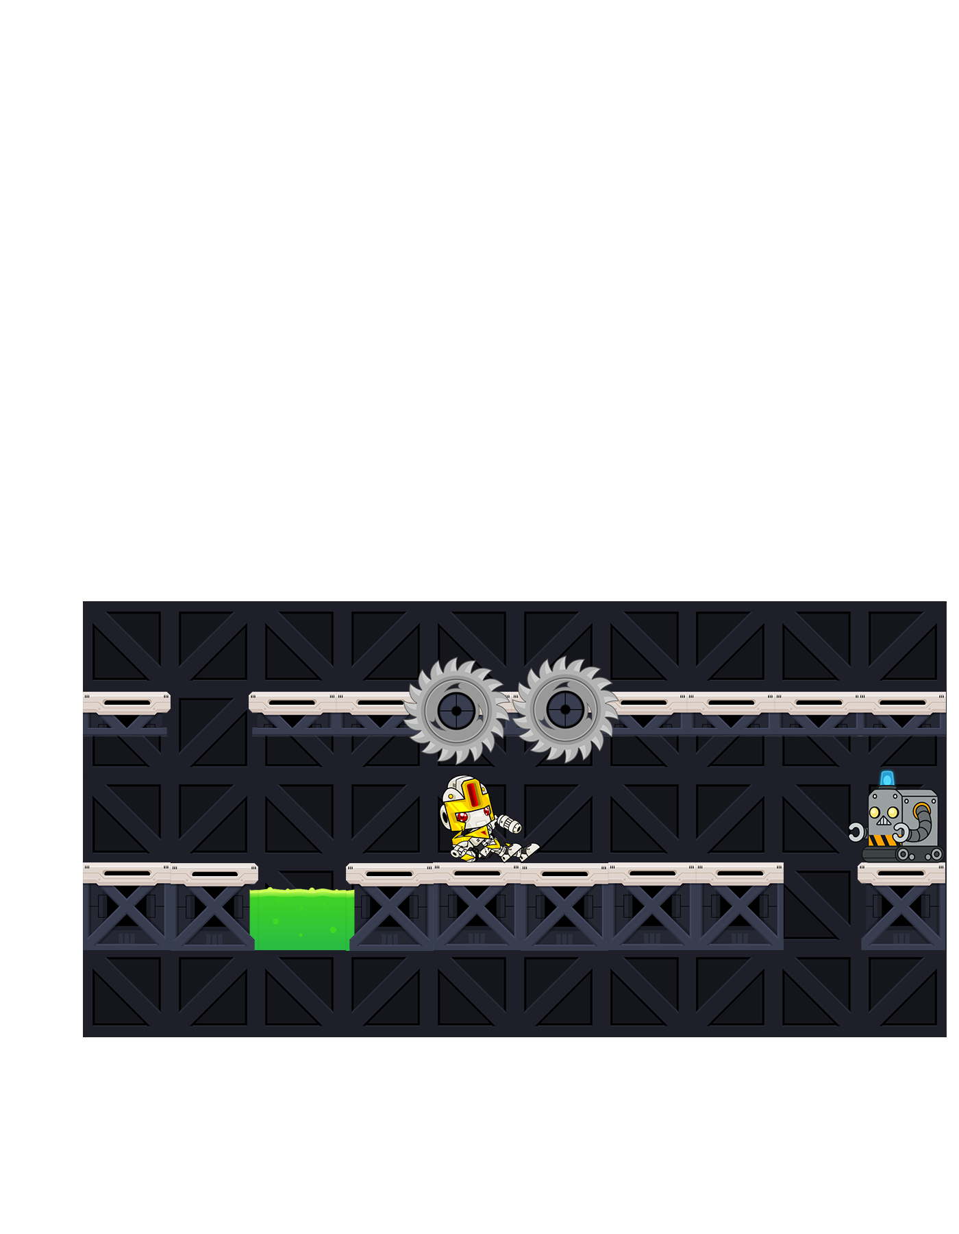**This screen shows how the player will need to use certain movements to avoid the traps generated by the game. In this example the player needed to jump over the acid and slide under the saws.**

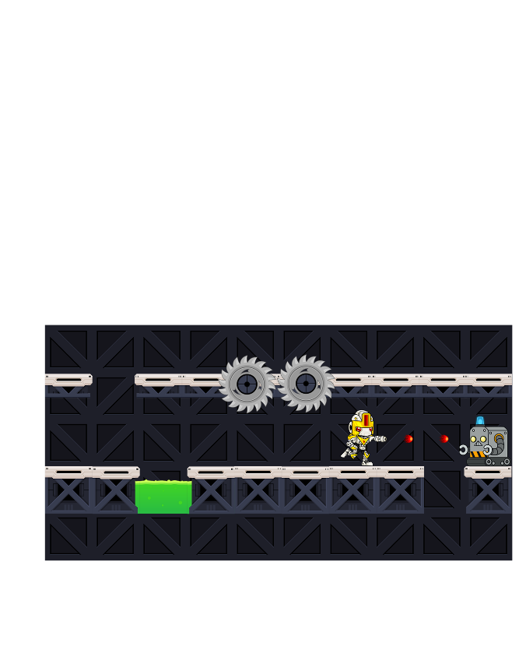**This screen shows how the player will interact with the enemies. They can shoot at the target, which requires energy, or attack the enemy up close to melee the enemy if they are out of energy.**

## Implementation

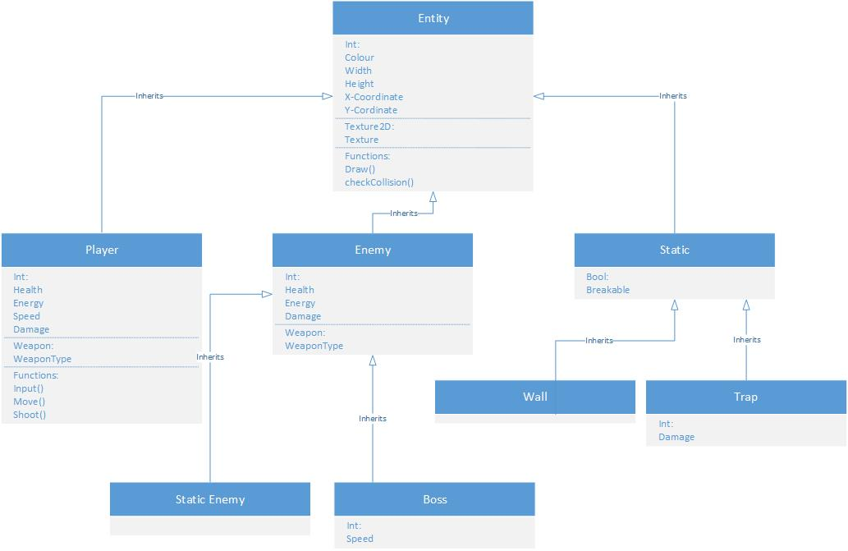**Here I have created a diagram to show the classes I plan to use within the game, and how the classes with inherit from each other.**

## Random Generation

This game will use an element of randomness to increase the re-playability and create an element of surprise to each playthrough. The gaps in the platforms will be randomly generated so that the player never knows what will come next, thus always putting pressure on the player. To implement this random generation, I will use markers that will each be assigned a number. For example, when the game renders a new row, a number is randomly chosen between the minimum and maximum set of markers. The game will then draw platforms all the way to the chosen number, and when it hits that chosen number will not draw a platform. After missing a platform, it will then fill in the rest of the platforms for that row. To further implement this, I will begin to use more random numbers to choose if there is more than one gap for that row, and if the gaps will be more than one unit big. However, I will be sure that the game does not randomly generate in a way that would make it impossible for the player to progress.